"""
Compare All Models: Linear Regression, Random Forest, XGBoost, Neural Network
Find the best model for price prediction
"""

import pandas as pd
import numpy as np
import matplotlib.pyplot as plt
import seaborn as sns
from sklearn.linear_model import LinearRegression
from sklearn.ensemble import RandomForestRegressor
from xgboost import XGBRegressor
from sklearn.neural_network import MLPRegressor
from sklearn.model_selection import train_test_split
from sklearn.preprocessing import StandardScaler
from sklearn.metrics import mean_absolute_error, mean_squared_error, r2_score
import time
import warnings
warnings.filterwarnings('ignore')

print("="*80)
print("MODEL COMPARISON FOR PRICE PREDICTION")
print("="*80)

# 1️⃣ Load and prepare data
print("\n📂 Loading data...")
df = pd.read_excel('/content/for python.xlsx')

feature_cols = ['nr_healthcare', 'nr_skytrain', 'nr_school', 'amt_bathroom', 'size', 'district_group', 'type']
target_col = 'price'

df_clean = df[feature_cols + [target_col]].dropna()
X = df_clean[feature_cols].copy()
y = df_clean[target_col]

# One-hot encode categorical variables
X_encoded = pd.get_dummies(X, columns=['district_group', 'type'], drop_first=False)

# Split data
X_train, X_test, y_train, y_test = train_test_split(
X_encoded, y, test_size=0.3, random_state=12345
)

print(f"✓ Data loaded: {len(X_train)} train, {len(X_test)} test samples")
print(f"✓ Features: {X_train.shape[1]} (after one-hot encoding)")

# Dictionary to store results
results = {}

print("\n" + "="*80)
print("TRAINING MODELS...")
print("="*80)

# 2️⃣ LINEAR REGRESSION
print("\n[1/4] 📊 Linear Regression...")
start_time = time.time()
lr_model = LinearRegression()
lr_model.fit(X_train, y_train)
lr_time = time.time() - start_time

lr_train_pred = lr_model.predict(X_train)
lr_test_pred = lr_model.predict(X_test)

results['Linear Regression'] = {
'train_mae': mean_absolute_error(y_train, lr_train_pred),
'train_rmse': np.sqrt(mean_squared_error(y_train, lr_train_pred)),
'train_r2': r2_score(y_train, lr_train_pred),
'test_mae': mean_absolute_error(y_test, lr_test_pred),
'test_rmse': np.sqrt(mean_squared_error(y_test, lr_test_pred)),
'test_r2': r2_score(y_test, lr_test_pred),
'time': lr_time,
'predictions': lr_test_pred
}
print(f" ✓ Complete in {lr_time:.2f}s")
print(f" Train R²: {results['Linear Regression']['train_r2']:.4f} | Test R²: {results['Linear Regression']['test_r2']:.4f}")

# 3️⃣ RANDOM FOREST
print("\n[2/4] 🌲 Random Forest...")
start_time = time.time()
rf_model = RandomForestRegressor(
n_estimators=100,
max_depth=10,
random_state=12345,
n_jobs=-1,
verbose=0
)
rf_model.fit(X_train, y_train)
rf_time = time.time() - start_time

rf_train_pred = rf_model.predict(X_train)
rf_test_pred = rf_model.predict(X_test)

results['Random Forest'] = {
'train_mae': mean_absolute_error(y_train, rf_train_pred),
'train_rmse': np.sqrt(mean_squared_error(y_train, rf_train_pred)),
'train_r2': r2_score(y_train, rf_train_pred),
'test_mae': mean_absolute_error(y_test, rf_test_pred),
'test_rmse': np.sqrt(mean_squared_error(y_test, rf_test_pred)),
'test_r2': r2_score(y_test, rf_test_pred),
'time': rf_time,
'predictions': rf_test_pred
}
print(f" ✓ Complete in {rf_time:.2f}s")
print(f" Train R²: {results['Random Forest']['train_r2']:.4f} | Test R²: {results['Random Forest']['test_r2']:.4f}")

# 4️⃣ XGBOOST (with regularization)
print("\n[3/4] 🚀 XGBoost (Regularized)...")
start_time = time.time()
xgb_model = XGBRegressor(
n_estimators=50,
max_depth=3,
learning_rate=0.05,
subsample=0.7,
colsample_bytree=0.7,
min_child_weight=5,
gamma=1,
reg_alpha=1,
reg_lambda=1,
random_state=12345,
n_jobs=-1,
verbosity=0
)
xgb_model.fit(X_train, y_train)
xgb_time = time.time() - start_time

xgb_train_pred = xgb_model.predict(X_train)
xgb_test_pred = xgb_model.predict(X_test)

results['XGBoost'] = {
'train_mae': mean_absolute_error(y_train, xgb_train_pred),
'train_rmse': np.sqrt(mean_squared_error(y_train, xgb_train_pred)),
'train_r2': r2_score(y_train, xgb_train_pred),
'test_mae': mean_absolute_error(y_test, xgb_test_pred),
'test_rmse': np.sqrt(mean_squared_error(y_test, xgb_test_pred)),
'test_r2': r2_score(y_test, xgb_test_pred),
'time': xgb_time,
'predictions': xgb_test_pred
}
print(f" ✓ Complete in {xgb_time:.2f}s")
print(f" Train R²: {results['XGBoost']['train_r2']:.4f} | Test R²: {results['XGBoost']['test_r2']:.4f}")

# 5️⃣ NEURAL NETWORK (with scaling)
print("\n[4/4] 🧠 Neural Network...")
start_time = time.time()

# Scale features and target for neural network
scaler_X = StandardScaler()
scaler_y = StandardScaler()

X_train_scaled = scaler_X.fit_transform(X_train)
X_test_scaled = scaler_X.transform(X_test)
y_train_scaled = scaler_y.fit_transform(y_train.values.reshape(-1, 1)).ravel()
y_test_scaled = scaler_y.transform(y_test.values.reshape(-1, 1)).ravel()

ann_model = MLPRegressor(
hidden_layer_sizes=(50, 20),
max_iter=1000,
random_state=12345,
early_stopping=True,
validation_fraction=0.2,
verbose=False
)
ann_model.fit(X_train_scaled, y_train_scaled)
ann_time = time.time() - start_time

# Transform predictions back to original scale
ann_train_pred = scaler_y.inverse_transform(
ann_model.predict(X_train_scaled).reshape(-1, 1)
).ravel()
ann_test_pred = scaler_y.inverse_transform(
ann_model.predict(X_test_scaled).reshape(-1, 1)
).ravel()

results['Neural Network'] = {
'train_mae': mean_absolute_error(y_train, ann_train_pred),
'train_rmse': np.sqrt(mean_squared_error(y_train, ann_train_pred)),
'train_r2': r2_score(y_train, ann_train_pred),
'test_mae': mean_absolute_error(y_test, ann_test_pred),
'test_rmse': np.sqrt(mean_squared_error(y_test, ann_test_pred)),
'test_r2': r2_score(y_test, ann_test_pred),
'time': ann_time,
'predictions': ann_test_pred
}
print(f" ✓ Complete in {ann_time:.2f}s")
print(f" Train R²: {results['Neural Network']['train_r2']:.4f} | Test R²: {results['Neural Network']['test_r2']:.4f}")

# 6️⃣ CREATE COMPARISON TABLE
print("\n" + "="*80)
print("📊 DETAILED PERFORMANCE COMPARISON")
print("="*80)

comparison_df = pd.DataFrame({
'Model': list(results.keys()),
'Train MAE': [f"{results[m]['train_mae']/1e6:.2f}M" for m in results.keys()],
'Train RMSE': [f"{results[m]['train_rmse']/1e6:.2f}M" for m in results.keys()],
'Train R²': [f"{results[m]['train_r2']:.4f}" for m in results.keys()],
'Test MAE': [f"{results[m]['test_mae']/1e6:.2f}M" for m in results.keys()],
'Test RMSE': [f"{results[m]['test_rmse']/1e6:.2f}M" for m in results.keys()],
'Test R²': [f"{results[m]['test_r2']:.4f}" for m in results.keys()],
'Time (s)': [f"{results[m]['time']:.2f}" for m in results.keys()]
})

print("\n" + comparison_df.to_string(index=False))
print("="*80)

# Find best model based on Test R²
best_model = max(results.keys(), key=lambda x: results[x]['test_r2'])
worst_overfitting = min(results.keys(), key=lambda x: abs(results[x]['train_r2'] - results[x]['test_r2']))

print(f"\n🏆 BEST MODEL (Highest Test R²): {best_model}")
print(f" Test R² = {results[best_model]['test_r2']:.4f}")
print(f" Test RMSE = {results[best_model]['test_rmse']/1e6:.2f}M Baht")

print(f"\n⚖️ MOST BALANCED (Least Overfitting): {worst_overfitting}")
print(f" Gap = {abs(results[worst_overfitting]['train_r2'] - results[worst_overfitting]['test_r2']):.4f}")

# 7️⃣ OVERFITTING ANALYSIS
print("\n" + "="*80)
print("🔍 OVERFITTING ANALYSIS")
print("="*80)

for model in results.keys():
train_r2 = results[model]['train_r2']
test_r2 = results[model]['test_r2']
gap = train_r2 - test_r2

if gap > 0.20:
status = "🔴 SEVERE overfitting"
elif gap > 0.10:
status = "🟡 Moderate overfitting"
elif gap > -0.05 and gap < 0.10:
status = "✅ Well-balanced"
else:
status = "✅ Good generalization"

print(f"{model:20s}: Train R²={train_r2:.4f} | Test R²={test_r2:.4f} | Gap={gap:+.4f} | {status}")

# 8️⃣ COMPREHENSIVE VISUALIZATIONS
fig = plt.figure(figsize=(16, 12))
gs = fig.add_gridspec(3, 3, hspace=0.35, wspace=0.3)

# Color scheme
colors = ['#3498db', '#2ecc71', '#e74c3c', '#f39c12']
model_names = list(results.keys())

# Plot 1: Test R² Comparison (MAIN METRIC)
ax1 = fig.add_subplot(gs[0, :2])
r2_scores = [results[m]['test_r2'] for m in model_names]
bars = ax1.bar(model_names, r2_scores, color=colors, alpha=0.8, edgecolor='black', linewidth=1.5)
ax1.set_ylabel('R² Score', fontsize=12, fontweight='bold')
ax1.set_title('🏆 Test R² Comparison (Higher is Better)', fontsize=14, fontweight='bold')
ax1.set_ylim([0, max(r2_scores) * 1.25])
ax1.grid(True, alpha=0.3, axis='y', linestyle='--')
ax1.axhline(y=0.5, color='red', linestyle='--', linewidth=1, alpha=0.5, label='Good threshold (0.5)')
for i, (bar, score) in enumerate(zip(bars, r2_scores)):
height = bar.get_height()
ax1.text(bar.get_x() + bar.get_width()/2., height + 0.02,
f'{score:.4f}',
ha='center', va='bottom', fontsize=11, fontweight='bold')
ax1.legend()

# Plot 2: Overfitting Check (Train vs Test R²)
ax2 = fig.add_subplot(gs[0, 2])
x_pos = np.arange(len(model_names))
train_r2 = [results[m]['train_r2'] for m in model_names]
test_r2 = [results[m]['test_r2'] for m in model_names]
width = 0.35

bars1 = ax2.bar(x_pos - width/2, train_r2, width, label='Train', alpha=0.8, color='#3498db')
bars2 = ax2.bar(x_pos + width/2, test_r2, width, label='Test', alpha=0.8, color='#e74c3c')
ax2.set_ylabel('R² Score', fontsize=11, fontweight='bold')
ax2.set_title('Overfitting Check', fontsize=12, fontweight='bold')
ax2.set_xticks(x_pos)
ax2.set_xticklabels(model_names, rotation=15, ha='right', fontsize=9)
ax2.legend()
ax2.grid(True, alpha=0.3, axis='y', linestyle='--')

# Plot 3: Test RMSE Comparison
ax3 = fig.add_subplot(gs[1, 0])
rmse_scores = [results[m]['test_rmse']/1e6 for m in model_names]
bars = ax3.bar(model_names, rmse_scores, color=colors, alpha=0.8, edgecolor='black', linewidth=1.5)
ax3.set_ylabel('RMSE (Million Baht)', fontsize=11, fontweight='bold')
ax3.set_title('Test RMSE (Lower is Better)', fontsize=12, fontweight='bold')
ax3.tick_params(axis='x', rotation=15)
ax3.grid(True, alpha=0.3, axis='y', linestyle='--')
for bar, score in zip(bars, rmse_scores):
height = bar.get_height()
ax3.text(bar.get_x() + bar.get_width()/2., height,
f'{score:.1f}M',
ha='center', va='bottom', fontsize=9)

# Plot 4: Training Time
ax4 = fig.add_subplot(gs[1, 1])
times = [results[m]['time'] for m in model_names]
bars = ax4.bar(model_names, times, color=colors, alpha=0.8, edgecolor='black', linewidth=1.5)
ax4.set_ylabel('Time (seconds)', fontsize=11, fontweight='bold')
ax4.set_title('Training Time', fontsize=12, fontweight='bold')
ax4.tick_params(axis='x', rotation=15)
ax4.grid(True, alpha=0.3, axis='y', linestyle='--')
for bar, t in zip(bars, times):
height = bar.get_height()
ax4.text(bar.get_x() + bar.get_width()/2., height,
f'{t:.2f}s',
ha='center', va='bottom', fontsize=9)

# Plot 5: MAE Comparison
ax5 = fig.add_subplot(gs[1, 2])
mae_scores = [results[m]['test_mae']/1e6 for m in model_names]
bars = ax5.bar(model_names, mae_scores, color=colors, alpha=0.8, edgecolor='black', linewidth=1.5)
ax5.set_ylabel('MAE (Million Baht)', fontsize=11, fontweight='bold')
ax5.set_title('Test MAE (Lower is Better)', fontsize=12, fontweight='bold')
ax5.tick_params(axis='x', rotation=15)
ax5.grid(True, alpha=0.3, axis='y', linestyle='--')
for bar, score in zip(bars, mae_scores):
height = bar.get_height()
ax5.text(bar.get_x() + bar.get_width()/2., height,
f'{score:.1f}M',
ha='center', va='bottom', fontsize=9)

# Plot 6-9: Actual vs Predicted for each model
for idx, model in enumerate(model_names):
ax = fig.add_subplot(gs[2, idx if idx < 3 else 0])
preds = results[model]['predictions']
ax.scatter(y_test, preds, alpha=0.5, s=20, color=colors[idx])
ax.plot([y_test.min(), y_test.max()], [y_test.min(), y_test.max()],
'r--', lw=2, alpha=0.7)
ax.set_xlabel('Actual Price', fontsize=9)
ax.set_ylabel('Predicted', fontsize=9)
ax.set_title(f'{model}\nR²={results[model]["test_r2"]:.3f}', fontsize=10, fontweight='bold')
ax.grid(True, alpha=0.3)
ax.ticklabel_format(style='scientific', axis='both', scilimits=(0,0))

plt.suptitle('Complete Model Comparison: Price Prediction',
fontsize=16, fontweight='bold', y=0.995)
plt.show()

# 9️⃣ FINAL RECOMMENDATIONS
print("\n" + "="*80)
print("💡 RECOMMENDATIONS")
print("="*80)

print("\n📌 Based on your requirements, choose:")
print(f"\n1. FOR BEST ACCURACY: {best_model}")
print(f" → Highest Test R² = {results[best_model]['test_r2']:.4f}")

print(f"\n2. FOR INTERPRETABILITY: Linear Regression")
print(f" → You can explain coefficients to stakeholders")
print(f" → Test R² = {results['Linear Regression']['test_r2']:.4f}")

print(f"\n3. FOR SPEED: Linear Regression")
print(f" → Fastest training = {results['Linear Regression']['time']:.2f}s")

print(f"\n4. FOR BALANCED PERFORMANCE: {worst_overfitting}")
print(f" → Best generalization with gap = {abs(results[worst_overfitting]['train_r2'] - results[worst_overfitting]['test_r2']):.4f}")

print("\n" + "="*80)
print("✅ Analysis Complete!")
print("="*80)
MODEL COMPARISON FOR PRICE PREDICTION
================================================================================

📂 Loading data...
✓ Data loaded: 700 train, 300 test samples
✓ Features: 11 (after one-hot encoding)

================================================================================
TRAINING MODELS...
================================================================================

[1/4] 📊 Linear Regression...
✓ Complete in 0.03s
Train R²: 0.3915 | Test R²: 0.5258

[2/4] 🌲 Random Forest...
✓ Complete in 0.68s
Train R²: 0.9403 | Test R²: 0.4996

[3/4] 🚀 XGBoost (Regularized)...
✓ Complete in 0.44s
Train R²: 0.6744 | Test R²: 0.5197

[4/4] 🧠 Neural Network...
✓ Complete in 0.38s
Train R²: 0.6276 | Test R²: 0.5226

================================================================================
📊 DETAILED PERFORMANCE COMPARISON
================================================================================

Model Train MAE Train RMSE Train R² Test MAE Test RMSE Test R² Time (s)
Linear Regression 14.35M 28.65M 0.3915 14.60M 25.85M 0.5258 0.03
Random Forest 4.33M 8.97M 0.9403 11.66M 26.55M 0.4996 0.68
XGBoost 10.24M 20.95M 0.6744 11.50M 26.01M 0.5197 0.44
Neural Network 10.63M 22.41M 0.6276 11.67M 25.93M 0.5226 0.38
================================================================================

🏆 BEST MODEL (Highest Test R²): Linear Regression
Test R² = 0.5258
Test RMSE = 25.85M Baht

⚖️ MOST BALANCED (Least Overfitting): Neural Network
Gap = 0.1050

================================================================================
🔍 OVERFITTING ANALYSIS
================================================================================
Linear Regression : Train R²=0.3915 | Test R²=0.5258 | Gap=-0.1344 | ✅ Good generalization
Random Forest : Train R²=0.9403 | Test R²=0.4996 | Gap=+0.4407 | 🔴 SEVERE overfitting
XGBoost : Train R²=0.6744 | Test R²=0.5197 | Gap=+0.1547 | 🟡 Moderate overfitting
Neural Network : Train R²=0.6276 | Test R²=0.5226 | Gap=+0.1050 | 🟡 Moderate overfitting
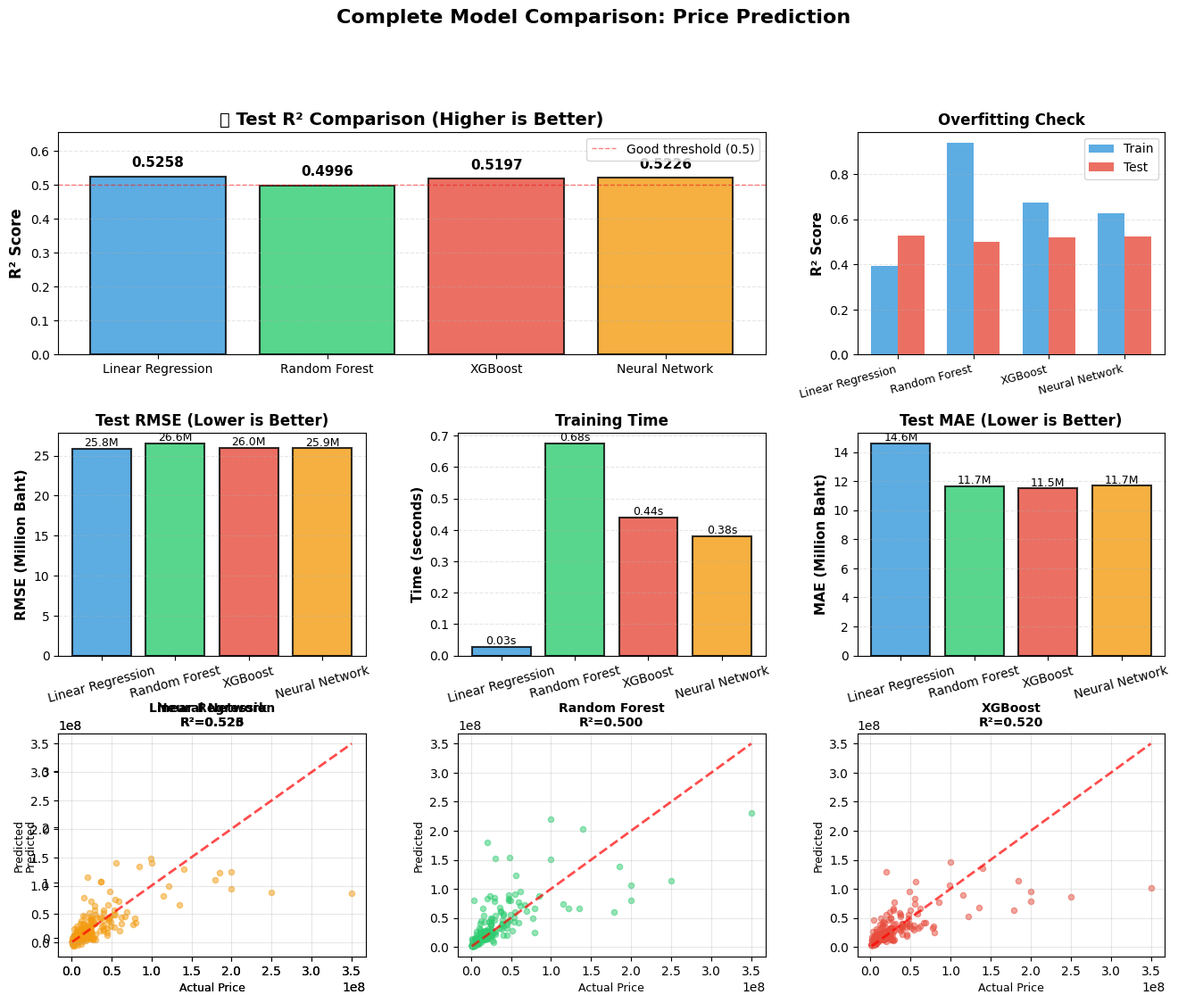

================================================================================
💡 RECOMMENDATIONS
================================================================================

📌 Based on your requirements, choose:

1. FOR BEST ACCURACY: Linear Regression
→ Highest Test R² = 0.5258

2. FOR INTERPRETABILITY: Linear Regression
→ You can explain coefficients to stakeholders
→ Test R² = 0.5258

3. FOR SPEED: Linear Regression
→ Fastest training = 0.03s

4. FOR BALANCED PERFORMANCE: Neural Network
→ Best generalization with gap = 0.1050

================================================================================
✅ Analysis Complete!
MODEL COMPARISON FOR PRICE PREDICTION
📂 Dataset Summary
- Training samples: 700
- Test samples: 300
- Features used: 11 (หลังจาก One-Hot Encoding)
- Target variable: price (ราคาบ้าน)

============================================================
Model Training Summary
Model | Train R² | Test R² | Training Time (s)
Linear Regression | 0.3915 | 0.5258 | 🟢 0.03
Random Forest | 0.9403 | 0.4996 | 0.68
XGBoost | 0.6744 | 0.5197 | 0.44
Neural Network | 0.6276 | 0.5226 | 0.38

🧠 Interpretation
- โมเดลทั้งหมดสามารถทำนายราคาบ้านได้ในระดับ R² ≈ 0.50–0.53
- Linear Regression ได้คะแนนสูงสุดในชุดทดสอบ (R² = 0.5258)
- Random Forest แม่นยำสูงมากในชุดฝึก (R² = 0.94) แต่ลดลงชัดเจนใน test → overfitting
- Neural Network มีความสมดุลดีที่สุด (train/test ใกล้กันมากที่สุด)
- XGBoost ทำได้ดีใกล้เคียงกับ Neural Network แต่ยัง overfit เล็กน้อย

============================================================
Detailed Performance Comparison
Model | Train MAE | Train RMSE | Test MAE | Test RMSE | Test R²
Linear Regression | 14.35M | 28.65M | 14.60M | 25.85M | 🟢 0.5258
Random Forest | 4.33M | 8.97M | 11.66M | 26.55M | 0.4996
XGBoost | 10.24M | 20.95M | 11.50M | 26.01M | 0.5197
Neural Network | 10.63M | 22.41M | 11.67M | 25.93M | 0.5226

🔍 Overfitting Analysis
Model | Train R² | Test R² | Gap | Interpretation
Linear Regression | 0.3915 | 0.5258 | -0.1344 | ✅ Good generalization
Random Forest | 0.9403 | 0.4996 | +0.4407 | 🔴 Severe overfitting
XGBoost | 0.6744 | 0.5197 | +0.1547 | 🟡 Moderate overfitting
Neural Network | 0.6276 | 0.5226 | +0.1050 | 🟡 Balanced, mild overfit

============================================================
Model Insights
📊 Linear Regression
- ✅ Best generalization performance (Test R² = 0.5258)
- ✅ Fastest model (train in 0.03s)
- ✅ Coefficients interpretable for stakeholders
- ⚠️ Assumes linearity — may not capture complex interactions
🌲 Random Forest
- ✅ Excellent fit on training data
- ⚠️ Severe overfitting — test accuracy drops significantly
- ⚠️ Model less interpretable
🚀 XGBoost
- ✅ Handles non-linear relationships
- ✅ Test R² = 0.5197 (close to best)
- ⚠️ Moderate overfitting
🧠 Neural Network
- ✅ Most balanced (smallest train-test gap)
- ✅ Robust generalization
- ⚠️ Requires more data tuning for better accuracy

============================================================
🏆 Summary of Best Models
Purpose | Recommended Model | Reason
Best Accuracy | 🥇 Linear Regression | Highest Test R² = 0.5258
Most Interpretable | 🧾 Linear Regression | Coefficients explainable
Fastest Training | ⚡ Linear Regression | Only 0.03s
Most Balanced | 🧠 Neural Network | Least overfitting (Gap = 0.105)

============================================================
Overall Conclusion
- ผลการเปรียบเทียบชี้ว่า Linear Regression เป็นโมเดลที่เหมาะสมที่สุดในภาพรวม
→ ทั้งเร็ว, แม่นยำ, และเข้าใจง่าย
- หากต้องการโมเดลที่ generalize ดีในข้อมูลใหม่ โดยยอมให้แม่นยำน้อยลงเล็กน้อย
→ Neural Network คือทางเลือกที่ดี
- Random Forest แม่นใน train มากแต่ไม่เสถียรใน test
- XGBoost อยู่ตรงกลาง — เหมาะกับข้อมูลที่มีความซับซ้อนและจำนวนตัวแปรมากกว่า

